**1.** Consider the following **Residual Plot**, is our linear model correct :

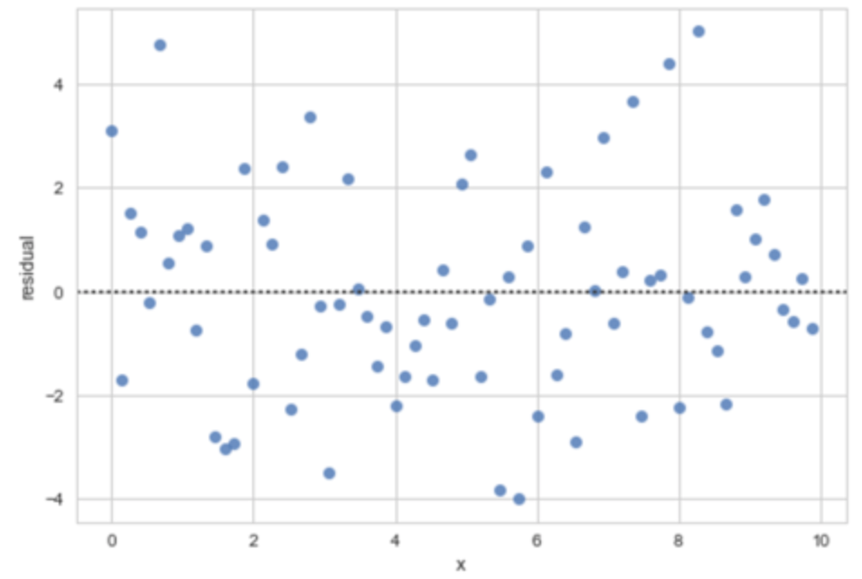

* yes
* incorrect